Fowler Middle School Library
Afterschool Club: L.E.A.P.’s Crown and Shield Club
Dates: First meeting Thursday, February 1st, 2018 and schedule to follow
Instructors: Officer Manchuso, tmanchuso@maynardpolice.com and Officer Ruggiero, mruggiero@maynardpolice.com
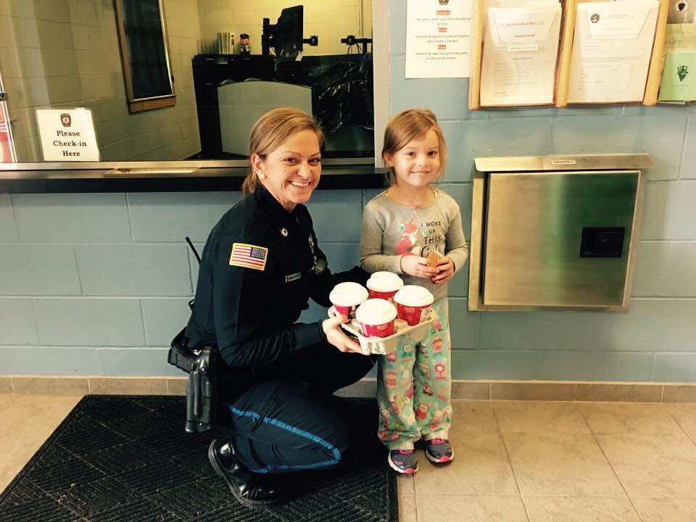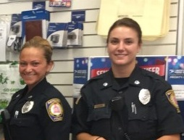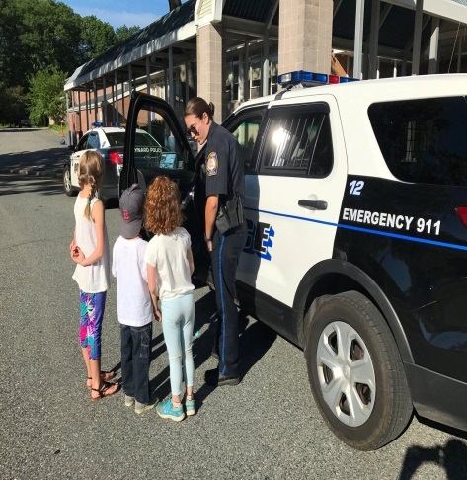
Dear Parents,
L.E.A.P.’s Crown and Shield Club is being offered once a month on Thursdays, beginning February 1st, 2018 with a schedule to follow. The club is designed to empower your girls with confidence building skills, touch on personal protection & self-defense, positive communication skills, talking about healthy choices & overall how to feel good about ourselves!
Students and Parents must fill-out the attached registration form prior to attending this club.
In the event of a cancellation (due to a scheduling conflict or an emergency on our end..(the woes of being a police officer!) we will have the school make an announcement and will also send a group e-mail to parents of daughters who attend Crown and Shield Club.
We are looking forward to empowering your girls! If you’re interested please have your girls sign up in the guidance office or email us!
Respectfully,
Officer Manchuso and Officer Ruggiero

Maynard Police Department
L.E.A.P.’s Crown & Shield Club: Starting Thursday, February 1st, 2018 & schedule to follow
Child’s Name: ________________________________________________
Parent/Guardian Name: ________________________________________________
Parent’s E-mail: ________________________________________________
Parent’s Cell Phone: ________________________________________________
Secondary Parent/Guardian Name: _________________________________________________
Secondary Parent/Guardian E-mail: _________________________________________________
Secondary Parent/Guardian Phone: _________________________________________________
Do you want the secondary parent/guardian notified of club updates and cancellations: Yes No
Emergency Contact (different from parent/guardian above):
Emergency Contact #1 – (Name/Relationship/Phone)
______________________________________________________________________________
Emergency Contact #2 – (Name/Relationship/Phone)
______________________________________________________________________________
I give permission for my child to attend this afterschool club (please sign and date)
______________________________________________ ______

Liability Waiver/Informed Consent Form
L.E.A.P. Programs: www.leapprogram.net
I, __________________________, give my child, _________________________, permission to participate in the L.E.A.P. Program “Crown and Shield” Club, offered by the Maynard Police Department through the Fowler Middle school.
I recognize this program involves physical activity including, but not limited to, walking, running, sports, games, yoga, and self-defense (various strikes and kicks utilizing martial arts pads and maneuvers will be offered).
I hereby affirm that my child is in good physical condition and does not suffer from any known disability or condition which would prevent or limit his/her participation in this program
I hereby agree that my child is participating solely at his/her own risk. I agree not to hold the Maynard Police Department, the Fowler Middle School, or the L.E.A.P Program, and/or any L.E.A.P. Instructor, responsible for any injury.
I understand that any of the activities involves a risk of injury. I am accepting such risks and volunteering my child to participate with full understanding of the dangers involved to include risk of serious injury or death.
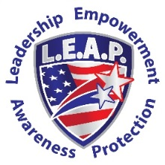
In consideration of my participation in this program, I, _____________________, hereby waive and release the Maynard Police Department, the Fowler Middle School, and the L.E.A.P. program, and/or any of its officers/agents, from any and all claims, costs, liability and expense for my child’s injury, loss or damage whether known, anticipated or unanticipated arising from my child’s voluntary participation and enrollment.
Additionally, I, and my child, agree to the following rules:
- This is a non-competitive environment
- Students will not engage in “horseplay.”
- Students will not use “excessive force” during the self-defense portion of this club.
- Students will act respectfully, and abide by the rules and community agreements set forth by instructors and class.
- Students will not use self-defense techniques outside of the training environment (unless during true exigent circumstances as described during training).
I, and my child, agree that failure to comply with the above rules is grounds for dismissal from the L.E.A.P. Program Crown and Shield Club.
I ACKNOWLEDGE THAT I HAVE THOROUGHLY READ THIS FORM IN ITS ENTIRETY AND FULLY UNDERSTAND IT. I UNDERSTAND THAT IT CONTAINS A RELEASE OF LIABILITY.
_________________________________ (Student Name)
_________________________________ (Parent Signature)
_________________________________ (Date)

